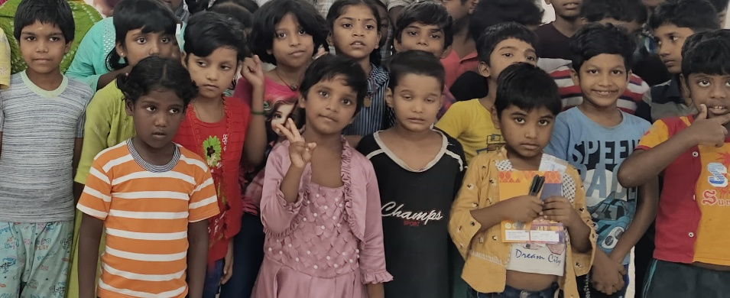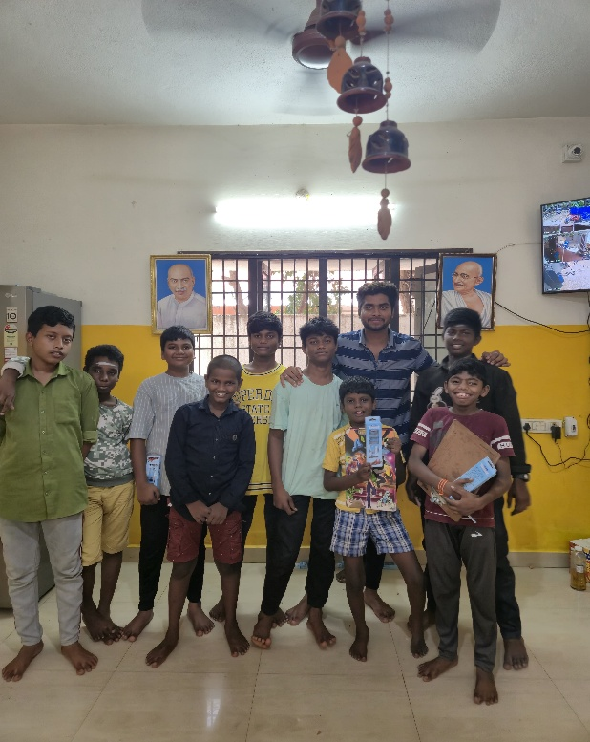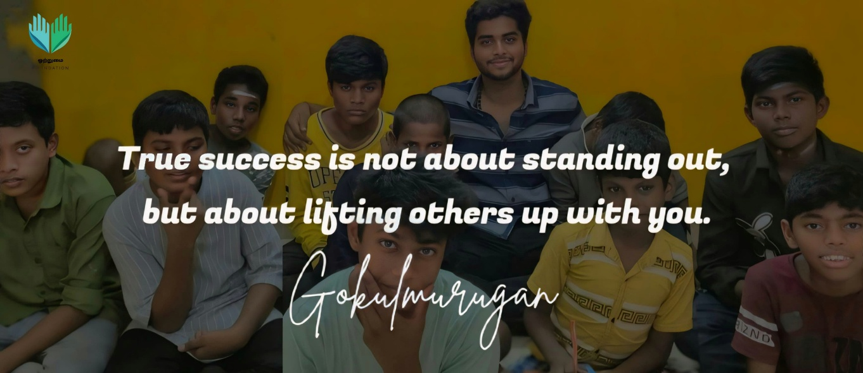

**Vision :**

Our vision is to create a united platform where service and knowledge go hand in hand. We aim to uplift lives through consistent social contributions and inclusive education, ensuring that no one is left behind in the journey toward a better tomorrow.

**Mission:**

We dedicate ourselves to empowering communities by offering meaningful social service initiatives and accessible learning opportunities. Through continuous engagement in volunteer-driven efforts and collaborative knowledge-sharing, we strive to foster a spirit of service, inspire positive change, spread joy, and contribute to the creation of a more inclusive and sustainable future for all.

**IMPACTFULL EVENTS**

**Period Pride – Awareness Session**

**April 18th 2024**  
An educational initiative focused on menstrual health and hygiene, featuring expert insights and open conversations. The session aimed to break taboos, spread awareness, and empower participants with knowledge about menstrual cycles, common myths, and when to seek help.

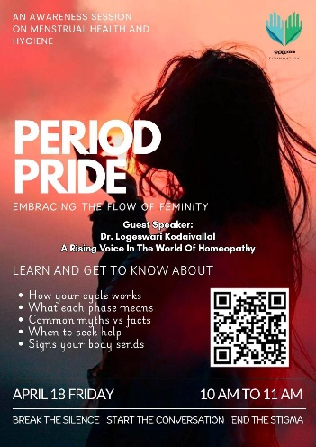

**Skill-Building Workshop – C Language**

**April 26th 2025**  
An interactive online workshop designed to introduce participants to the fundamentals of the C programming language. Led by keynote speaker Kavyadharshini S M, the session aimed to unlock the magic of C—where coding truly begins—offering practical knowledge to beginners at no cost.

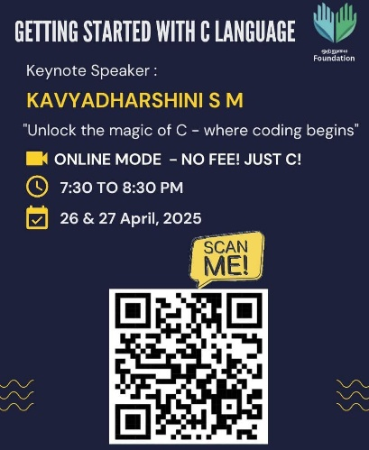

**Volunteer Drive – Food Donation Campaign**

**April 7th 2024**  
As part of our commitment to community welfare, volunteers from Otrumai Foundation organized food donation drives across multiple locations. Nutritious meals were distributed to residents of old age homes and underserved communities, spreading compassion and support to those in need. The initiative reflected our mission to serve with empathy and build a more caring society.

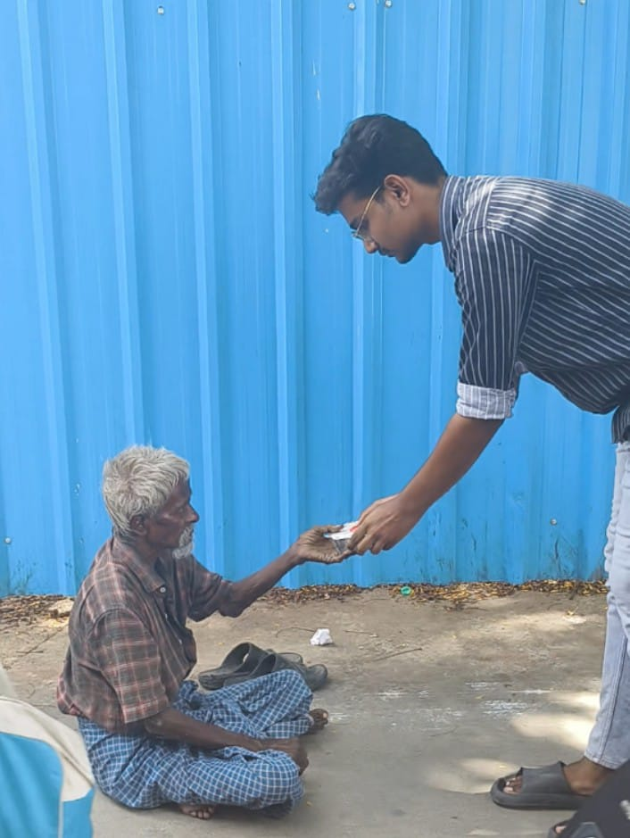

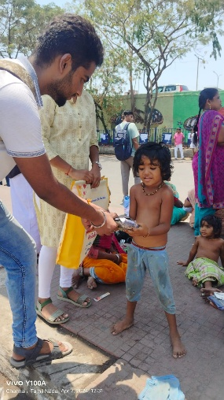

**Educational Events – Volunteer Project Showcase**

**April 12th 2025**

volunteers from the Otrumai Foundation organized a series of educational events where they showcased their innovative projects and talents. These events featured hands-on demonstrations and insightful presentations across various fields, including technology, sustainability, and social impact. Volunteers shared their expertise, inspiring attendees with practical knowledge and real-world applications. The initiative reflected our commitment to fostering creativity, collaboration, and knowledge-sharing within the community.

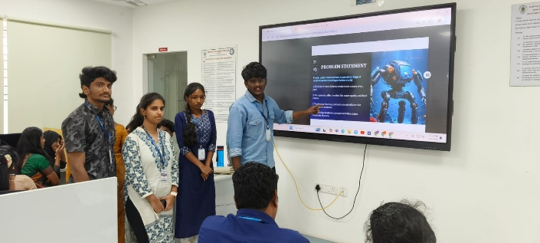

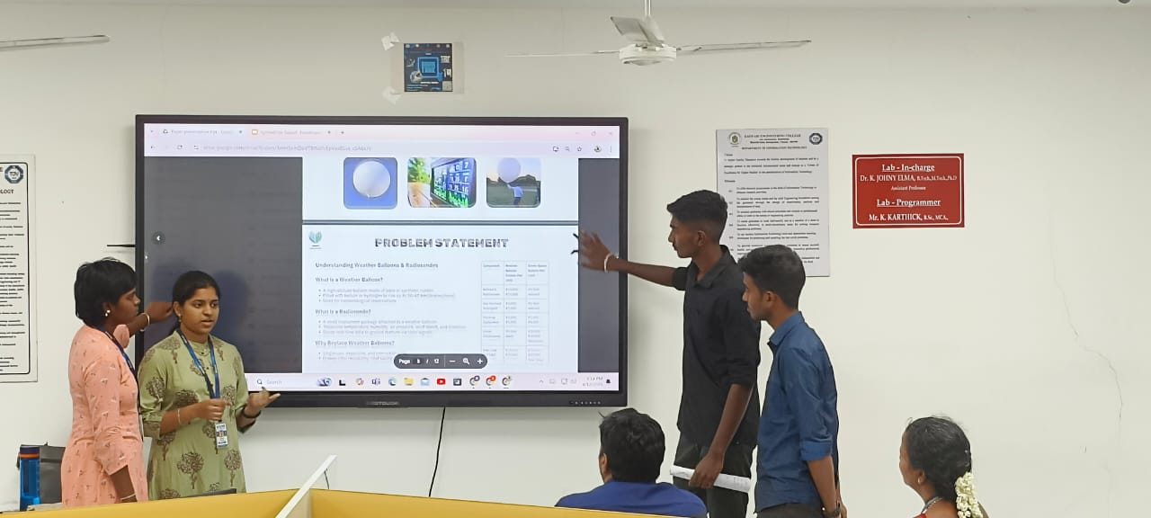

**Environmental Initiative – Beach Cleaning Drive**

**April 2nd 2025**  
Volunteers from Otrumai Foundation took part in a beach cleaning drive to promote a cleaner and healthier environment. The effort highlighted our commitment to sustainability and community-driven ecological care. Through such actions, we continue to advocate for sustainable living and environmental stewardship.

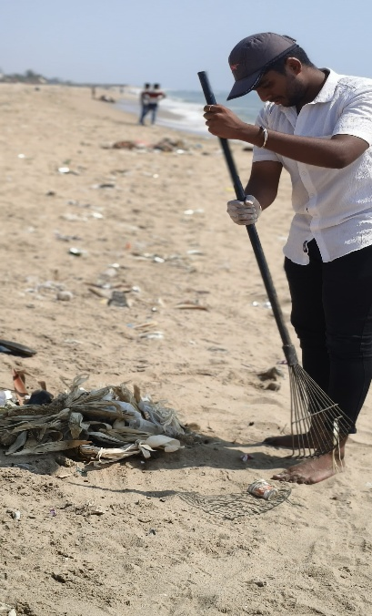

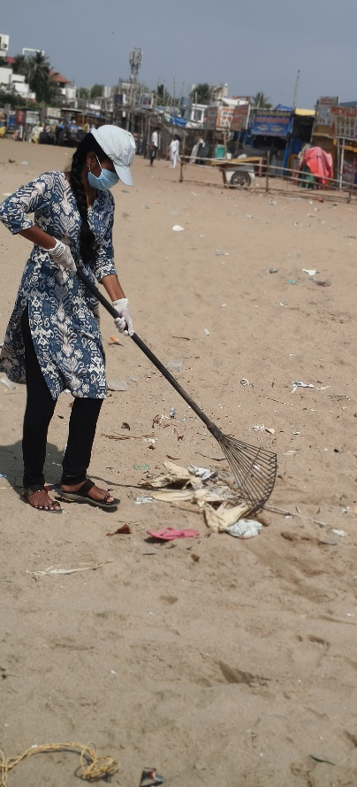

**GALLERY**

**World Health Day – Food Distribution Drive**

**7th April 2024**

**(Tambaram bus stand and railway station)**

"Everybody can be great, because everybody can serve." Embracing this spirit, Otrumai Foundation marked its first contribution on World Health Day by distributing **100 food packets** to those in need around Tambaram. This small act of kindness brought immense joy—not just to the recipients, but to every volunteer who witnessed their smiles and heartfelt blessings  
At Otrumai, we believe that no one should go hungry. Our mission is to serve the underserved and spread hope through meaningful action. Together, let’s feed the hungry and create a world rooted in empathy and unity.

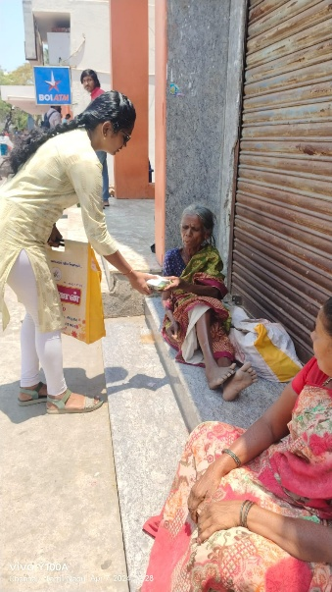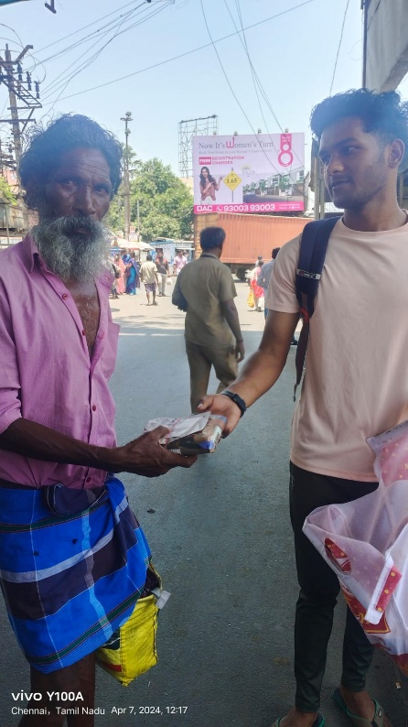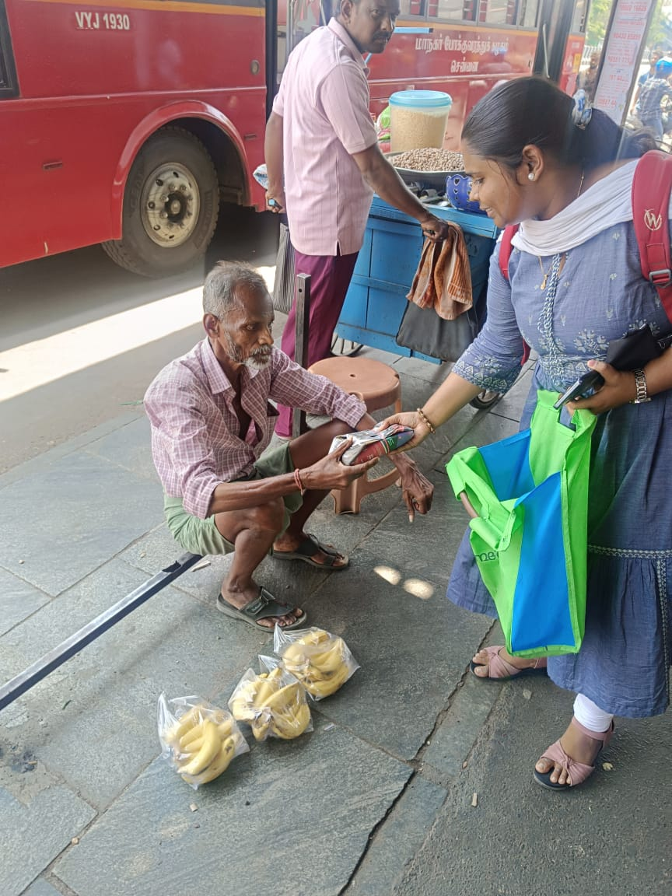

**Children’s Home Visit**

**16th June 2024**

**(Tambaram)**

As part of our commitment to nurturing young minds, Otrumai Foundation volunteers visited a children’s home, creating a joyful space filled with creativity and encouragement. A variety of engaging activities were organized, allowing the children to express themselves and showcase their unique talents. From art and dance to storytelling and more, each child shone in their own beautiful way.  
The day was a celebration of individuality, potential, and the joy of being seen and heard. It reminded us that with love, support, and opportunity, every child can thrive and inspire.

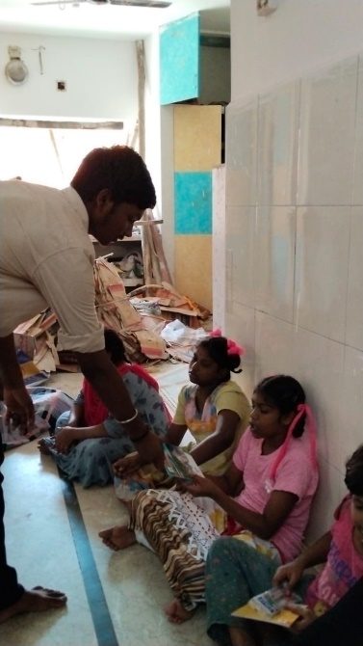

**Old Age Home Visit**

**19th August 2024**

**(Medavakkam)**

Otrumai Foundation volunteers visited an old age home, spending quality time with the senior residents through heartfelt conversations and meaningful interaction. As a small gesture of care, we distributed notebooks and pens, encouraging them to write, reflect, or simply engage in creative expression.  
The visit was a reminder of the wisdom, stories, and warmth our elders hold—and the joy that comes from simply being present with them.

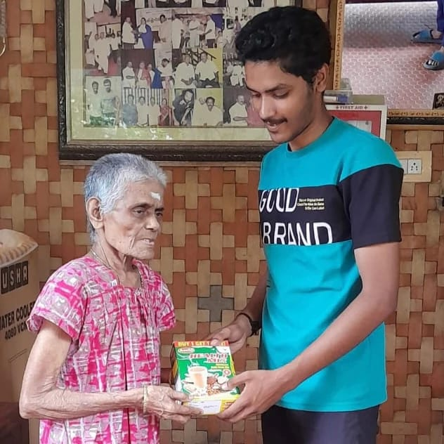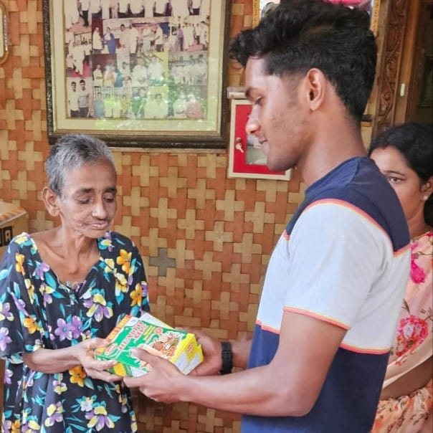

**Blanket & Clothes Donation Drive – Spreading Warmth During Crisis 2024**

**27th October 2024**

**(Chrompet and Camp Road)**  
In times of hardship, even the smallest act of kindness can bring immense comfort. During a recent crisis, Otrumai Foundation volunteers came together in solidarity to support individuals living without shelter. Understanding the urgent need, we distributed blankets and clothes nearly 50+ blankets and cloths to help them stay warm and protected.  
This drive was not just about material aid—it was about restoring dignity, offering hope, and standing with those who are often overlooked. Through compassion and collective effort, we aimed to bring a little warmth to those facing the coldest nights.  
**Together, we serve. Together, we care.**

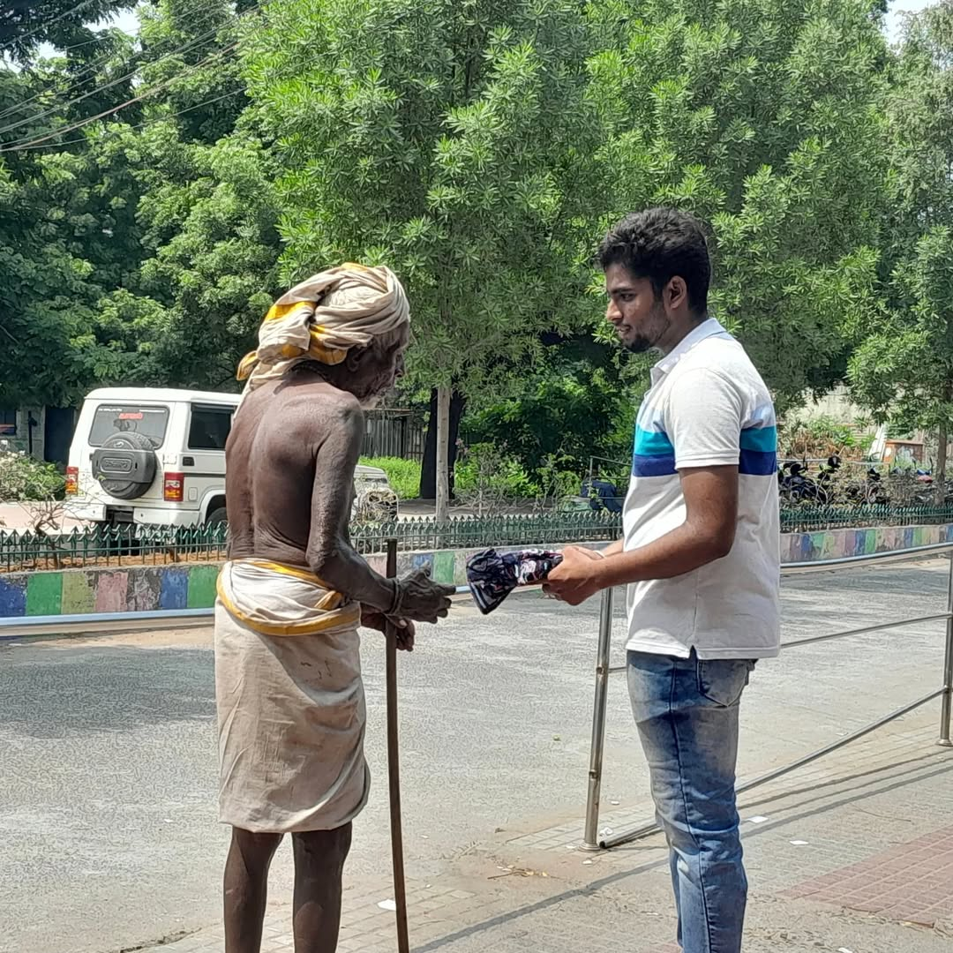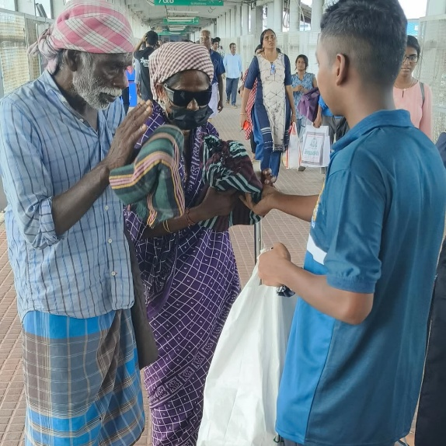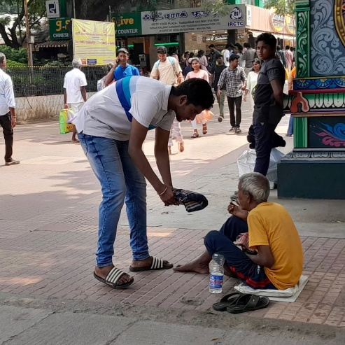

**Food Donation Drive**

**3rd November 2024**

**(Central Railway Station)**

In a world where many still struggle to afford even a single meal, Otrumai Foundation took a heartfelt step toward change. With the vision to combat poverty and hunger, our dedicated volunteers distributed nutritious food to those who cannot afford three meals a day.  
This initiative wasn’t just about feeding the hungry—it was a call to action, a reminder that no one deserves to go to bed hungry. Every meal served carried a message of hope, dignity, and solidarity.  
At Otrumai, we believe in a future where basic needs aren’t a privilege but a right.  
**Let’s stand together to feed lives and fight hunger.**

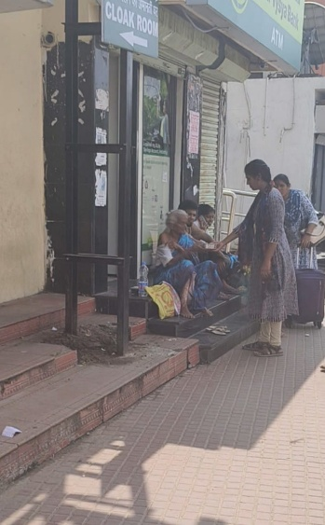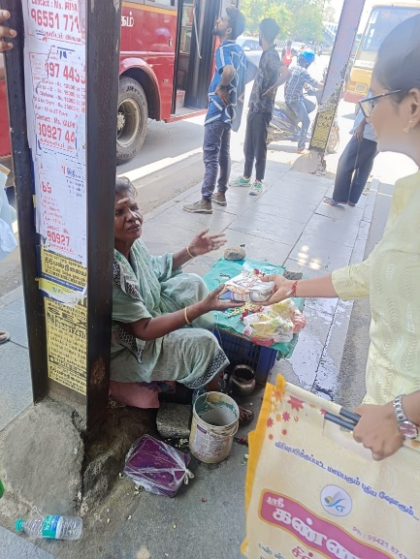

**Christmas Celebration Drive**

**25th December 2024)**

**(Vandalur)**

Otrumai Foundation embraced the spirit of Christmas by celebrating the festival of joy with the public, turning the day into a beautiful memory of shared happiness and unity. Volunteers came together to distribute chocolates, small gifts, and festive cheer, lighting up faces young and old alike. The celebration ended with a joyful cake-cutting ceremony that brought everyone closer in the warmth of the season.  
This initiative was more than a celebration—it was about spreading love, kindness, and a sense of belonging to those who need it most.  
Because joy grows when shared—and Christmas is the perfect time to give from the heart.

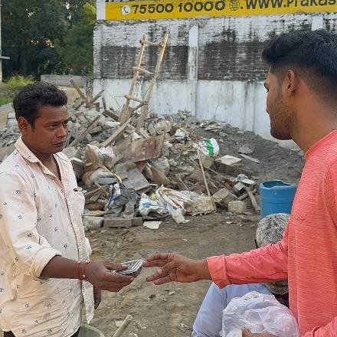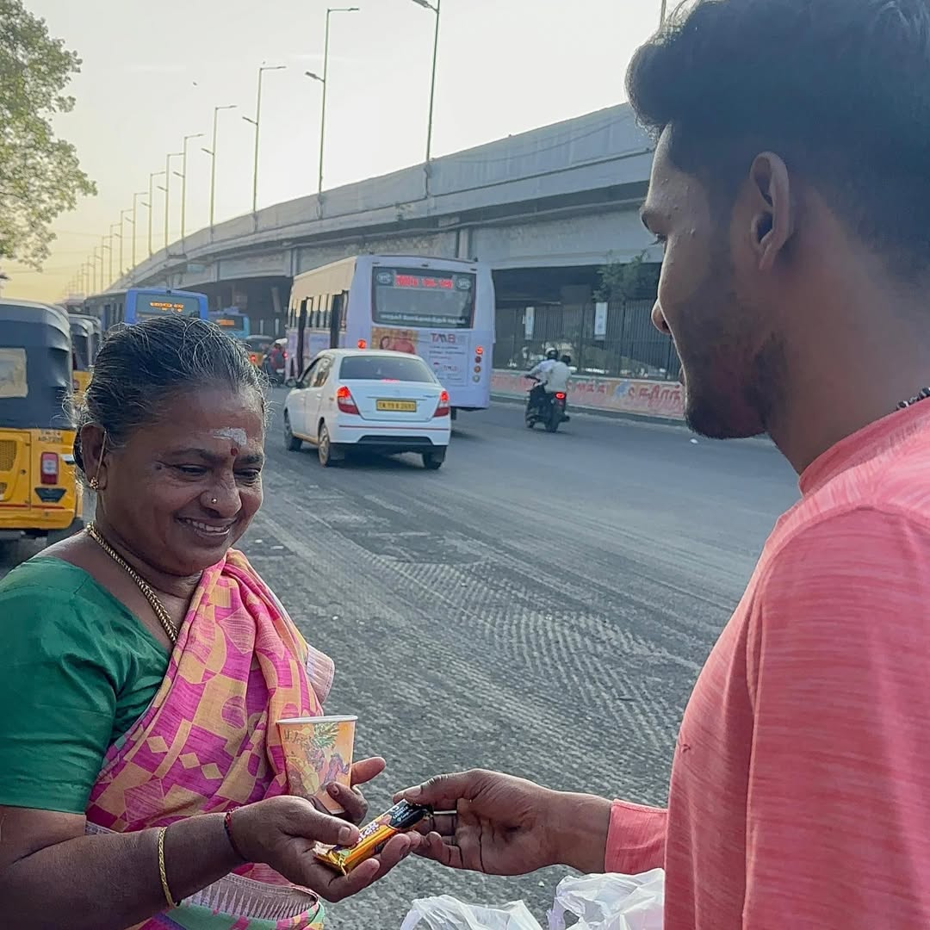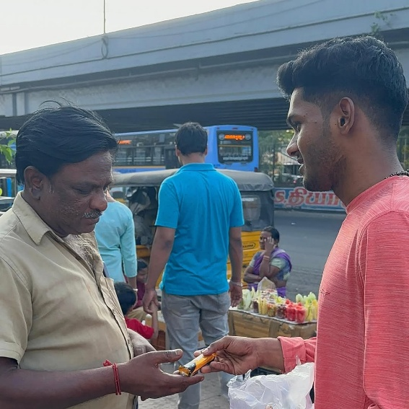

**Beach Cleaning Drive – A Step Toward a Greener Tomorrow**

**2nd April 2025**

**(Besant Nagar beach)**Volunteers from Otrumai Foundation joined hands to clean the beach, removing waste and restoring its natural beauty. This drive aimed to raise awareness about pollution and its impact on marine life.  
The event reflected our commitment to sustainability and community-driven environmental care. Each act of cleanup was a step toward a healthier, greener planet.  
**Let’s protect our earth—because change begins with us.**

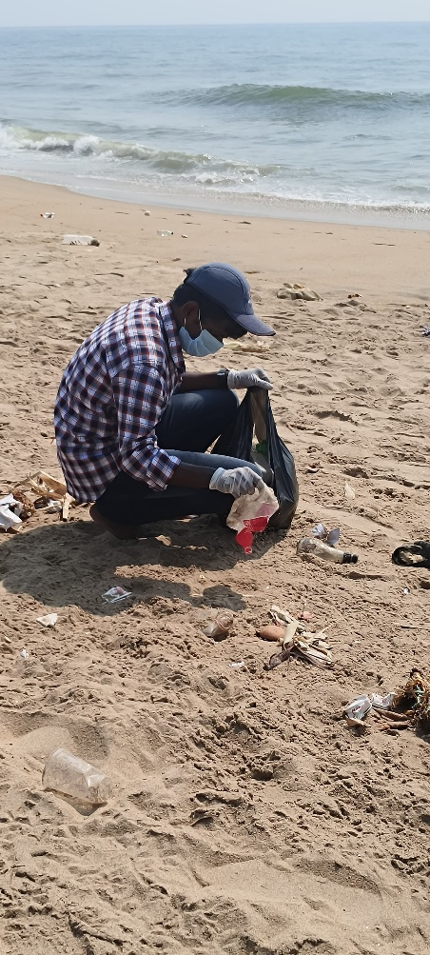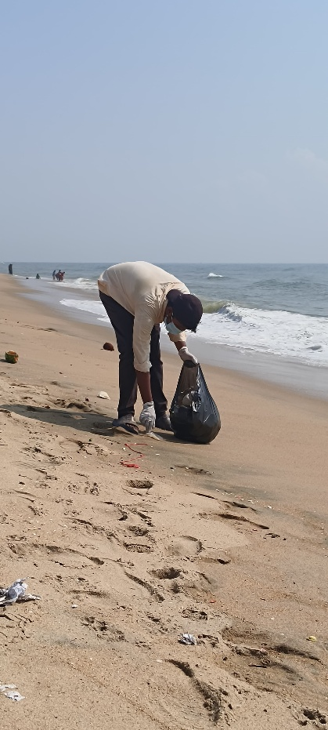

**Children’s Home Visit Drive**

**27th April 2025**

**(Kovilambakkam)**

Otrumai Foundation recently visited a children’s home, where we organized a series of fun and creative activities to encourage self-expression and build confidence. The children took part in a dance competition, showcasing their energy and creativity. Additionally, many expressed their talents through writing stories, drawing beautiful artworks, and participating in other activities.  
At Otrumai, we believe in empowering children and fostering an environment where they can grow, create, and dream. **Together, we nurture hope and creativity in the next generation.**

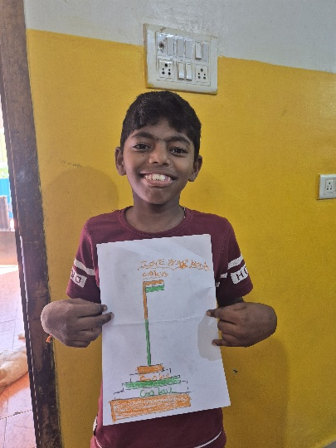

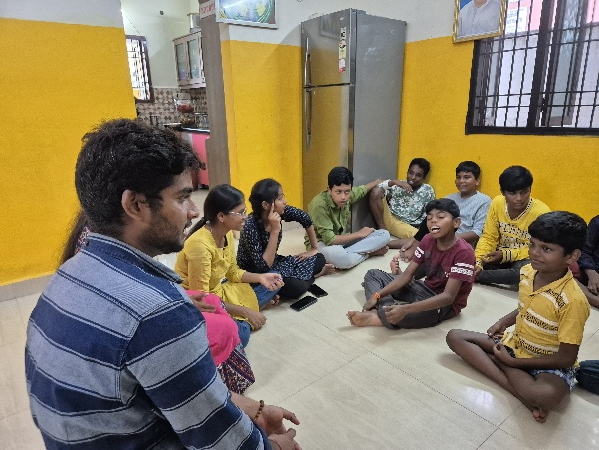

**FEEDBACK THAT FUELS OUR PASSION**

1.khaveya

2.Swetha

3.Padamavathi

4.Krithik

**MAIL ID:** **otrumaifoundation@gmail.com**

**Instagram:** [**https://www.instagram.com/otrumai_foundation?igsh=MW50NGc1d3B0aGRoZA==**](https://www.instagram.com/otrumai_foundation?igsh=MW50NGc1d3B0aGRoZA==)

**Linkedin:** [**https://www.linkedin.com/in/%E0%AE%92%E0%AE%B1%E0%AF%8D%E0%AE%B1%E0%AF%81%E0%AE%AE%E0%AF%88-foundation-77609b322?utm_source=share&utm_campaign=share_via&utm_content=profile&utm_medium=android_app**](https://www.linkedin.com/in/%E0%AE%92%E0%AE%B1%E0%AF%8D%E0%AE%B1%E0%AF%81%E0%AE%AE%E0%AF%88-foundation-77609b322?utm_source=share&utm_campaign=share_via&utm_content=profile&utm_medium=android_app)

Volunteers 500+

Local Chapters 11

Families Helped 650+